***Schedule Builder Quick-Start Guide***

***Schedule Builder*** is a new tool for students and advisors built into the Highpoint upgrade to DKU Hub. When in the student view you can find it under the *Enrollment* heading on the left hand side.

What makes this tool valuable is that if a user inputs the courses they need into it the schedule builder it will look at the combinations of times over both sessions to find combinations of classes that work and provide recommendations of sections that can fit a student’s schedule.

Courses can be added multiple ways. A user can search for each course individually or, if they have partially enrolled or placed courses into their shopping cart, they can import them from other locations.

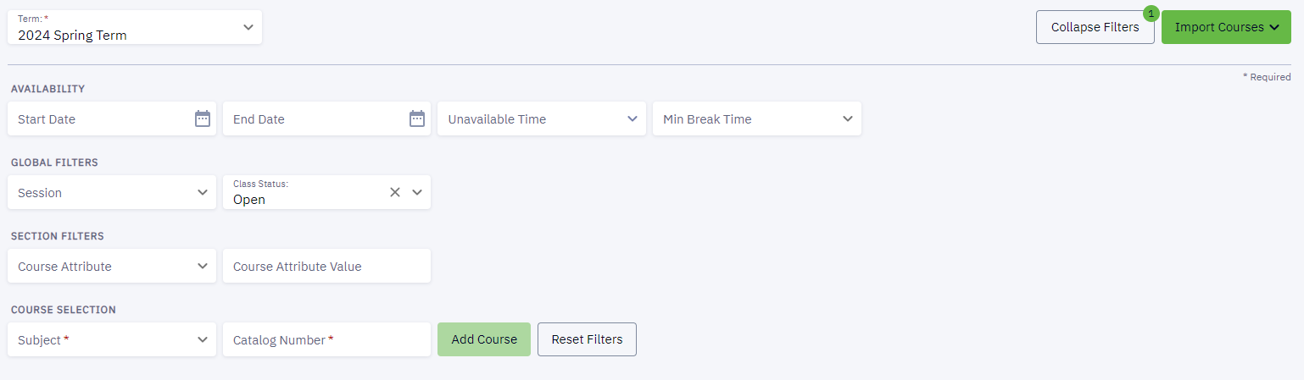

This example student will be a second-semester international Freshman who needs to do GCHINA 101, their second language, and some exploratory Arts & Humanities coursework. Many of these classes have lots of sections so deciding on specific schedule could be challenging, especially when they are all still currently open (options will shrink as classes fill). They’ve decided on the following 16 credits for this semester:

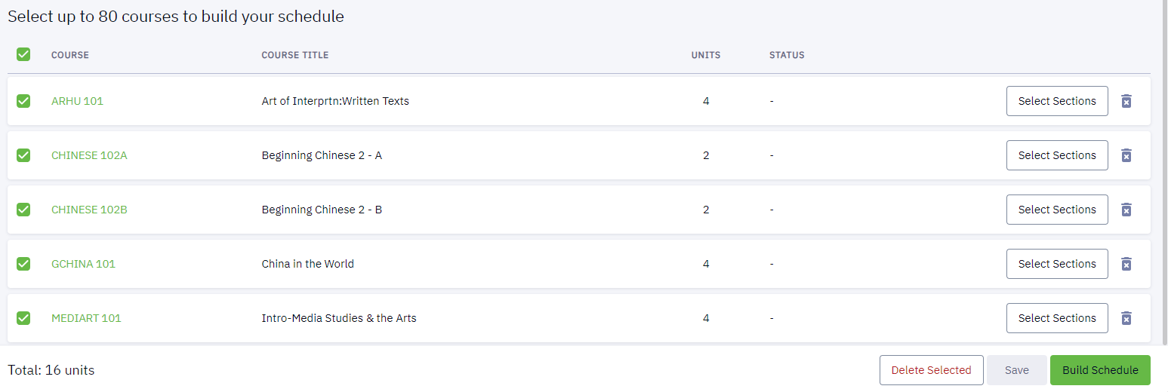

On hitting “Build Schedule” there may be some errors, often due to holds since the advising meeting will take place before an advisor will have pulled the hold. There are other errors though, such as this top one telling the user that Chinese 102A has prerequisites which have not been met and requires a co-requisite of 102B. If you understand these issues and will have them resolved before registration begins then feel free to hit “Continue.” If these cannot be resolved it may be wise to choose other course options.

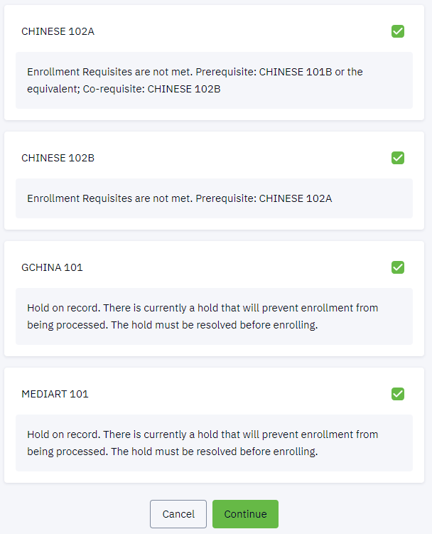

Because there are so many sections in each of these classes this search returns many versions of the schedule that will work for the student. These can be sorted in multiple ways (top right), saved as a favorite schedule, or marked as a schedule they’d like to compare with other options (both top left).

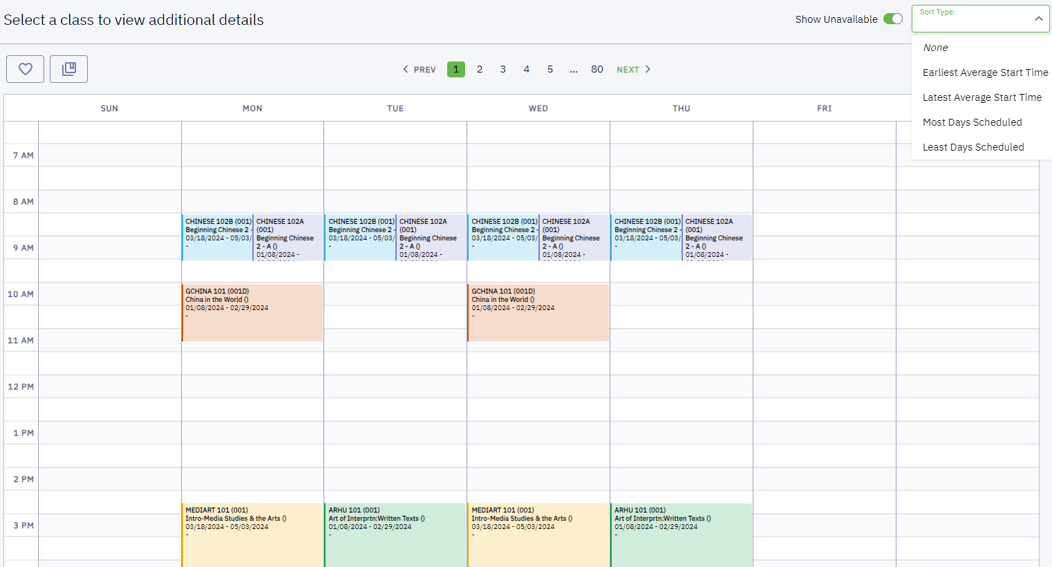

Courses matched on schedule builder will not cause time conflicts but will overlap visually if they are at the same times in different sessions. When this happens they will be clearly marked so it’s apparent which class happens in each.

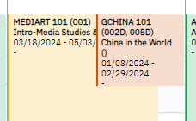

Users can also scroll down on a given schedule to see the breakdown in a different way over the entire semester.

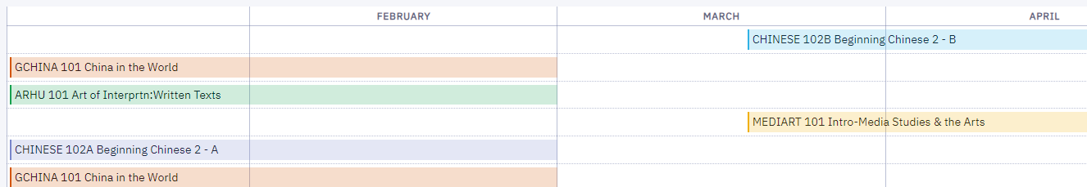

At this stage the user can simply click through the different options to see which version of the schedule they like best. Once that has been identified they can simply write down the sections they would like to take or they can save a class as a favorite. Multiple favorites can be saved under any name the user chooses. Once that is done a schedule listed as a favorite can be sent to the shopping cart or be enrolled in directly (if the student is doing this when their registration window is open).

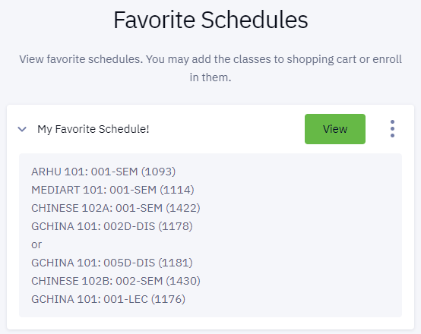

There are a number of other features built into the schedule builder. For a more detailed user guide provided by the vendor please visit the UG Advising Sakai Site and look under the Registration Guides folder for the *Schedule Builder User Guide*.